***Fly Creeker***

**NEWSLETTER of the FLY CREEK AREA HISTORICAL SOCIETY (FCAHS)**

**www:https//flycreekareahistoricalsociety.org**

**President: Greg Crowell, 607-547-2802; hfcrowell@gmail.com**

**Editor: Bill Deane, 607-547-4426; billdeane14@gmail.com**

**VOLUME 37, ISSUE 2 * SPRING, 2025**

**NEWS BRIEFS**

* **Working It …** As part of the annual reopening of our FCAHS/Grange building, we will be holding a “work day” on Wednesday, April 16, starting at 10 AM. Coordinator Sharon Kroker says the duties needed include “dusting, sweeping, mopping and a good scrubbing of the kitchen and items that will be used to prepare and serve food for the pancake breakfast.  Many hands make light work, so if you are able to help out, we would really appreciate it.”
* **Break the Fast …** Our spring Pancake Breakfast is scheduled for Sunday, May 4, 8 AM until noon at the FCAHS/Grange building on 208 Cemetery Road, Fly Creek. Besides pancakes, the all-you-can-eat breakfast includes sausage & gravy, scrambled eggs, home fries, biscuits, cider, juice, and coffee, all for a historically-low price. Mark your calendars and bring your appetites! Event chairman Tony Kroker is looking for helpers and certain food contributions; please call him (802-345-5757) if you can help. All proceeds benefit the FCAHS in this fund/fun-raiser.
* **Preservation Reservation …** The Otsego County Historical Association and Maryland Historical Society are holding their annual “Partners in Preservation” event on Saturday, May 10, and the FCAHS will be represented with a table. The event will be held at the Unadilla Elementary School, 295 Main Street, Unadilla, from 10 AM to 2 PM. It brings together historians from various local villages, towns, and organizations to showcase their history. The theme is America 250 (i.e., the upcoming 250th anniversary of the United States), focusing on people and events from each town’s history. The event is free and open to the public. The Boy Scout Museum across the street will also be open that day and there will be no charge to the visitors. For further information, contact OCHA President Jan Bartow at jwbartow1@gmail.com.
* **Road Show at Home …** The FCAHS will be hosting an “Antiques Road Show” type fund-raising event on Sunday, June 22. It will be held from 11 AM to 3 PM at the FCAHS/Grange building, with Chris Brown on hand to appraise items (limit two per person) for a nominal fee. There will also be historical exhibits from several other area museums, and possibly food and music. More details will follow in local newspapers, posters, and our web-site.
* **Renew & Improved …** Thanks mostly to renewals, we have 64 names to add to the 2025 “roll of membership” printed in the last issue: James & Catherine Ainslie, Art & Bev Blessin, Doug Burleigh, Wesley & Evette Ciampo (P), Dora Cooke (C), Peter & Linda Craig, Bonnie Duval, John & Jean Finch*, Jeff & Fiona Fine, Fly Creek General Store (B), Neil & Mary Fogarty, Beverly Hargrove, Mary Ann Hartmann, Tom Heitz, Ed & Connie Hobbie, Sam & Peg Hoskins (C), Tom & Julie Huntsman/A Sweet Goodbye (B), David & Judith Jackson, Chris Kjolhede & Celeste Johns, Brian Leyde, Charles Malack & Nancy Merrell, Brad & Shelley Marcus (P), John & Susan McCullough, Kathryn Mollach (P), Carl Parshall, Robert & Kay Pierro (C), Tassha Rathbone & family, Richard & Diane Richardson, Ron & Paula Sarles, Genevieve Smerski, Katherine Snyder, Judy Steiner (C), Barbara Stephenson, Suzanne Summers, John & Mary Tedesco, Ellen Tillapaugh & Gary Kuch, Martin & Meg Tillapaugh (P), Doris Irons Treadway, Layne Weir & Toni Gray, Robert Winnie (C), and Jim Yourno. [B = business/professional; C = contributing/sustaining; P = Patron of History; * = charter members.] Thanks to all members for your continued support!

**(More news briefs on back page)**

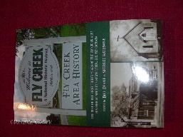***FLY CREEK AREA HISTORY***

Each issue, we will include an article from our 2022 book, *Fly Creek Area History*. A few copies of the book are still available at the FCAHS/Grange building ($20 for members), and at the Fly Creek General Store and Fly Creek Cider Mill ($25 plus tax for the general public). Copies can also be mailed in the continental US (library rate) for an additional $7 per book.

**TWO CENTURIES OF TENSION**

By Hugh C. MacDougall, Spring 1995

This 200-year-old article must be one of the earliest published references to Fly Creek, and suggests a certain light-hearted tension between Fly Creek and Cooperstown which has presumably endured for two centuries. It appeared in the April 17, 1795 issue (Volume 1, Number 3) of the *Otsego Herald*, and read as follows:

March 26th, 1795.

At a meeting of a large and respectable number of young men in Fly Creek settlement, OLD HEAD, *in the Chair.*

Resolved unanimously, that if any female within this settlement, attends a ball or associates with any young gentleman of Cooperstown, or any other place, without leave of the chairman, shall be debarred from all the privileges of this society, and be treated by every member of this meeting with the utmost scorn and detestation.

*Peter Prim, Clk.* Old Head *chairman*.

 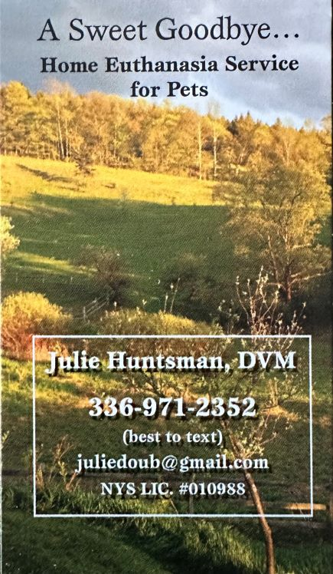 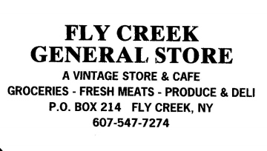

**MEETINGS & PROGRAMS**

The next three FCAHS monthly meetings are scheduled for April 23, May 28, and June 25, 2025. Meetings normally start at 6:30 PM at the FCAHS/Grange building at 208 Cemetery Road, Fly Creek.

In April, Gilbert Lake State Park volunteer Rich Ranieri will give a Power-Point presentation on the “History of the Civilian Conservation Corps.” In May, Cherry Valley Town and Village Historian Susan Murray-Miller will discuss “The Cherry Valley Massacre.” And in June, we will meet at the former Fly Creek Trolley Station at 187 Cemetery Road, where Les Sittler will give a history and tour of that building, before we proceed to our own home for the regular meeting. More details will follow in local newspapers, posters, and our web-site.

The three most recent meetings were held on January 22, February 26, March 26, 2025. In January, County Historian Deb Mackenzie gave a lively and entertaining program on “Legends and Leaders of Otsego County.” She discussed 15 people who were on the fringes of U.S. and world history, and who had ties to our county (including Fly Creek’s Col. Cato Freeman, about whom she promises to tell us more in a future *Fly Creeker* article). February featured our annual “Show & Tell” program, with items ranging from an 1858 letter to a 1990 Fly Creek Bicentennial T-shirt. And in March, long-time Town of Otsego Historian Tom Heitz explained “The Fly in Fly Creek.” He shared theories as to the origin of the hamlet’s name, and detailed a failed 1894 effort by John B. Hooker, Jr., to get the name changed to Fenimore or Otsego. The rallying cry for the majority was “Fly Creek forever; Fenimore, never!”

**FREIDA SNYDER, 1925-2025**

The FCAHS mourns the death of Freida Snyder, founding member of our Society. Freida died at her Fly Creek home on March 29, less than six months before her 100th birthday.

Freida Putnam was born in South Valley on September 16, 1925, and married Arthur Snyder on February 24, 1946. They moved to Hoke Road, Fly Creek in 1955, running a dairy farm and raising four children. After the Snyders sold the dairy, Freida worked as a postal clerk at the Fly Creek Post Office. Art died on October 11, 2012.

Freida and Art were among the 55 original members when the FCAHS was formally chartered on July 26, 1989. Freida was one of just five who was still a member 36 years later, and was an active one almost to the end. She preferred to stay out of the limelight (which is why this obituary isn’t on the front page), but was always doing things behind the scenes to support our Society. Freida was a regular attendee at our monthly meetings and special events, and was still helping at our pancake breakfast and a work day last October at age 99. As recently as January, Freida helped fold, stamp, and label our last newsletter for mailing.

Freida, along with Elaine Harvey, served as our Programs Committee for the first 13+ years of our history. Freida also served on our Publications Committee for many years, contributing “A Treasured Chest” (Summer 1993) to our newsletter and book, *Fly Creek Area History*. The Board of Trustees granted her lifetime membership in 2014, with the following resolution, which tells more about her contributions:

**Whereas,** this Board, after discussion during its September 3, 2014 meeting, finds that Freida Snyder of Hoke Road, Fly Creek

has been a valued member of the Fly Creek community for many decades, and

**Whereas,** Freida and her husband Art were charter members of the Fly Creek Area Historical Society, and

**Whereas,** Freida has been the most faithful attendee of FCAHS meetings since 1989, and

**Whereas,** Freida served as a Society Trustee from 2010-13, and

**Whereas,** Freida has served many years on the Society’s Programs, Archives, Publications, and Fundraising Committees, and

**Whereas,** Freida has donated countless time and money toward the Society’s fundraisers, special events, archives, and exhibits,

and

**Whereas,** Freida did the artwork for the Society’s gift cards and for the Fly Creek bicentennial postal cancellation envelopes,

**Now, therefore,** be it resolved that Freida Snyder be granted Lifetime Membership to the Fly Creek Area Historical Society.

The foregoing resolution unanimously adopted under the authority of the Fly Creek Area Historical Society Board of Trustees.

We extend our condolences to Freida’s friends and family, including four children, nine grandchildren, twelve great-grandchildren, and three great-great-grandchildren. And especially to daughters Kathy Snyder and Janice Millea, who continue the tradition of Snyders active with the Society. Freida will be dearly missed.

**FROM THE ARCHIVES**

By Deecy Haviland

**Each issue, we will plan to feature an item from our FCAHS Museum collection. The museum is open during FCAHS monthly meetings and special events, and by appointment (deecy2650@gmail.com).**

When George A. Bailey died in 1921, it was obvious from reading his obituary that he was a learned and well-respected man. He had worked as an undertaker for 32 years in Fly Creek at the time of his death at age 66. His wife, former neighbor Lily Taylor, died a year later. They had no children.

Many of the official U.S. Census records list George A. Bailey not as an undertaker, but as a farmer. His great-grandfather Charles (1751-1826) was the first family member to live in Otsego County. He was trained as a carriage maker in Yorkshire, England, but came to America in 1805 after a five-week voyage from England with his wife, Sarah, and two young sons, John and Roger (see *Fly Creek Area History*, p. 178-79). After meeting wheat farmer Daniel Brown, Charles moved his family from Albany to Otsego County. He purchased 90 acres of land from Judge William Cooper, on the east bank of Fly Creek just north of the village, in the vicinity of today’s Bailey Road. This was where the family farmed for many decades. By 1850 the Bailey family, headed by Roger Bailey (1787-1863, our undertaker’s grandfather) owned more than 300 acres of land in Fly Creek, where they raised sheep and dairy cows and grew mostly hops and flax.

George A. Bailey’s old undertaker’s business sign and a casket from his shop (once located at the corner General Store) now reside in the Fly Creek Area Historical Society Museum**.**

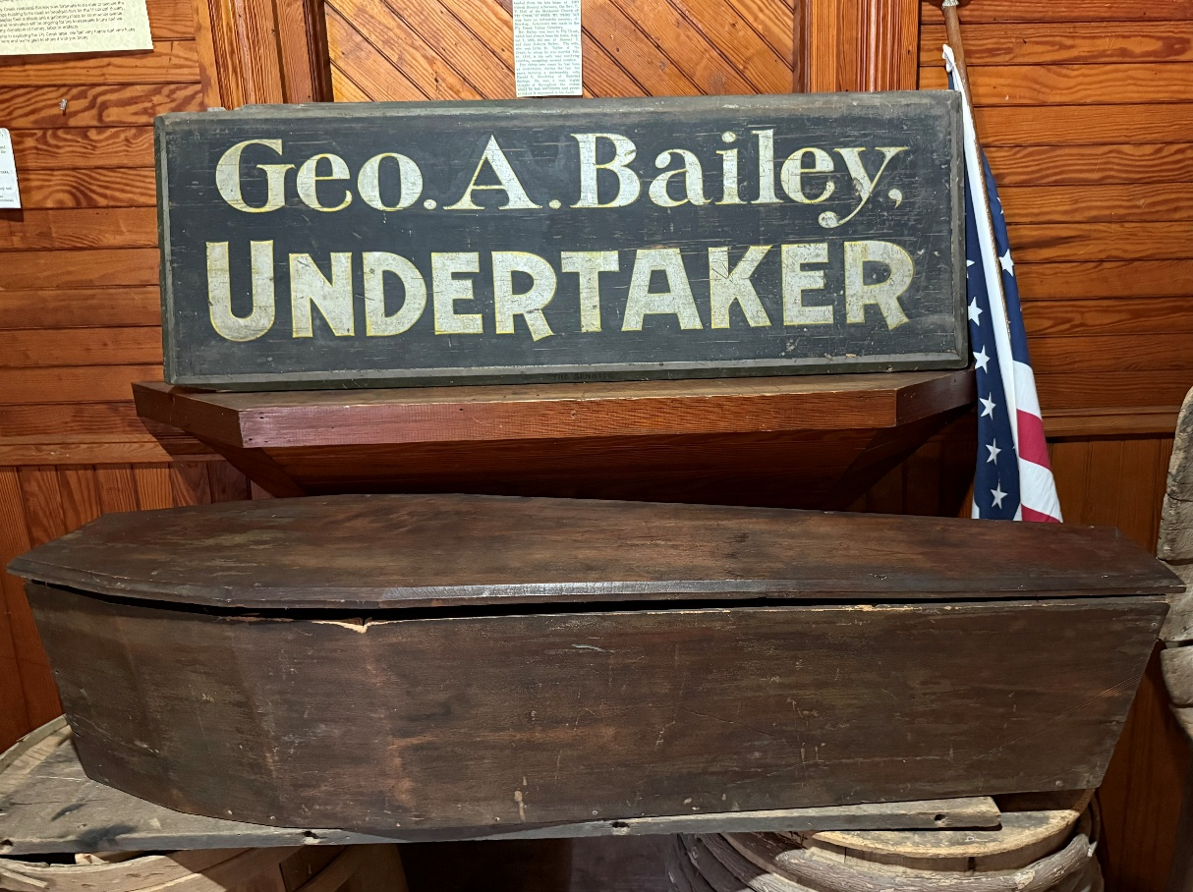



**LETTERS TO THE EDITOR**

The *Fly Creeker* will print letters of general interest about area history, the Society, or the newsletter itself. The Editor reserves the right to edit letters for grammar, space, etc. Address correspondence to Bill Deane, at 408 Christian Hill Road, Cooperstown, NY 13326; or e-mail to billdeane14@gmail.com.

I am attaching part of a January 26 article from our local Portland, Maine newspaper. It is about *USA Today*’s “Best Readers’ Choice Awards,” including the best cidery:

“In business since the 1850s, Fly Creek Cider Mill & Orchard offers a truly massive array of both food and drink products for Upstate New York visitors and locals to sample. Beyond treats like fudge, dumplings and cookies, cider is a particularly popular liquid refreshment for guests, with the drink available in both hard and alcohol-free varieties.”

Fly Creek Cider Mill & Orchard is a star!

    Give my regards to all in Fly Creek.

Diantha Cushman Harrington, Kennebunk, ME

Many thanks for this. I love getting local news, it keeps me in touch with what is going on. Even though I am not a native to the Fly Creek area, my late husbands, Gene Hecox and Elliot “Ruby” Helfand, were and their families still are there at least part of the year. When I married them I was accepted as a resident and made so very welcome, I still consider it my second home. I am so happy for local news and so glad too that the FCAHS is still alive well and active. Missing you all and glad you are still here for so many of us.

Martha “Marty” Helfand, Fort Myers, FL

My great-grandfather, Irving D. Marsh, lived in Fly Creek with his wife, Elmina (Amy) Adams Marsh, and family in the late 1800s.  I’ve found a lot of information about Elmina (daughter of Eli Barlett Adams and Betsey Spencer Long); however, I’ve found very very little about Irving. I’ve exhausted my search by finding his parents/siblings (father Floyd, brothers John and Silas), where they were from, life details, etc. on Ancestry, FamilySearch, and many other similar sites online. From what I’ve found, Irving was born in Pennsylvania on June 6, 1862, married Elmina about 1887, had at least four children, and lived in the Fly Creek/Cooperstown area until his passing in 1908.  He was also a charter member and gatekeeper of Fly Creek Grange No. 844.

Please provide information about my family if possible or lead me in the right direction. Your help would be forever appreciated.

Tom Dakota (twd1165@yahoo.com)

I recently purchased a property at 931 County Highway 26 here in Fly Creek, the dark brown house right across from the Cider Mill.  I’m reaching out to see if your organization might have any historical information or records about the house or the surrounding area.

The property has a unique charm, and I’d love to learn more about its past owners, architectural history, or any notable events connected to it.  If you have any details or could point me in the right direction for research, I’d greatly appreciate it.

Thank you for the work you do in preserving Fly Creek’s history.  Please let me know if there are any resources, documents, or meetings I might be able to access.

Mark Lann, Texas (786-412-4131; mlann0210@gmail.com)

I’m doing some research on veterans from Cooperstown and surrounding areas. Do you happen to have any military records or photos I could look at?

Joan Parrillo-Hotaling (joanie_hotaling@yahoo.com)

**NEWS BRIEFS (Continued from page 1)**

* **Lady Ostapeck …** Sometime this summer,the FCAHS will be hosting an exhibit of work by Fly Creek photo artist, Lady Ostapeck (1918-2017). If you have any of her photos to lend, or stories about your experiences working with her, please share them with us!
* **Topping it Off …** Our historic building’s roof is in urgent need of repair/replacement, and will cost us more than $30,000. There are other imminent building repair needs as well. We are exploring grants to help with these, but are required to first seek donations from the community. As we are a 501(c)(3) non-profit organization, contributions are tax-deductible. Please consider donating what you can, and getting the word out to other community members. Also, we are seeking members for our Finance Committee to help in applying for grants. Thanks to those who have already contributed a total of $6,566, and apologies to anyone who was offended by the identification of donors in the last issue.
* **Building for Rent …** The FCAHS has set a fee schedule for rental of its building. For full-day use, the rate is $200 for profit-making organizations, $100 for 501 C (3) non-profit organizations, $75 for the general public, and $50 for FCAHS members; the respective rates for half-day use are $100, $50, $37.50, and $25. There is no fee for FCAHS-sponsored events. A security deposit equal to the user fee, and proof of $250,000 liability insurance, are required. There are also fees for a custodian ($15/hour, minimum $60), and for heat, if required ($50). Contact the FCAHS President for further information.
* **Help Wanted …** Since getting our web-site up and running, we’ve received a number of requests for information about the history of people and places in our area. Three are included in the “letters to the editor” on page 5. Can anyone help these people?
* **Getting on Board …** The next quarterly meeting of the FCAHS Board of Trustees is scheduled for July 8 at 3 PM at the Town building. Members are welcome to attend.

**---------------------------------------------------------------------------------------------------------------------**

**FLY CREEK AREA HISTORICAL SOCIETY**

**P.O. Box 87**

**Fly Creek, NY 13337**